1. 

It only appeared in the calculation of total distance.

1. P13 variable type 需要在前面加上说明
2. 我的部分我就不做主观修改了
3. 

Thus, due to the similarity between both processes, …; the aisles are maximally utilized in terms of parallelity.

1. 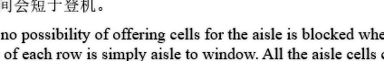

for 前面最好加逗号

1. 

缺个右括号

1. 

Once united in magnitudes, the dissatisfaction index can rather *equally* reflect the three aspects of passengers’ satisfaction.

1. 模拟结果部分我认为可以等会画一张python柱状图，然后同时放上这张图
2. 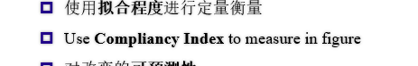

in concrete figures

1. 

Predictability

1. 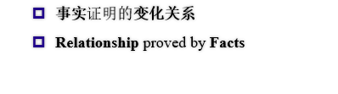

内容修改：事实->结论与模型

Facts-> Claims and our model